# Лабораторная работа №1 (Вариант 24)

Ус Владимир

2МО-1

Задания:

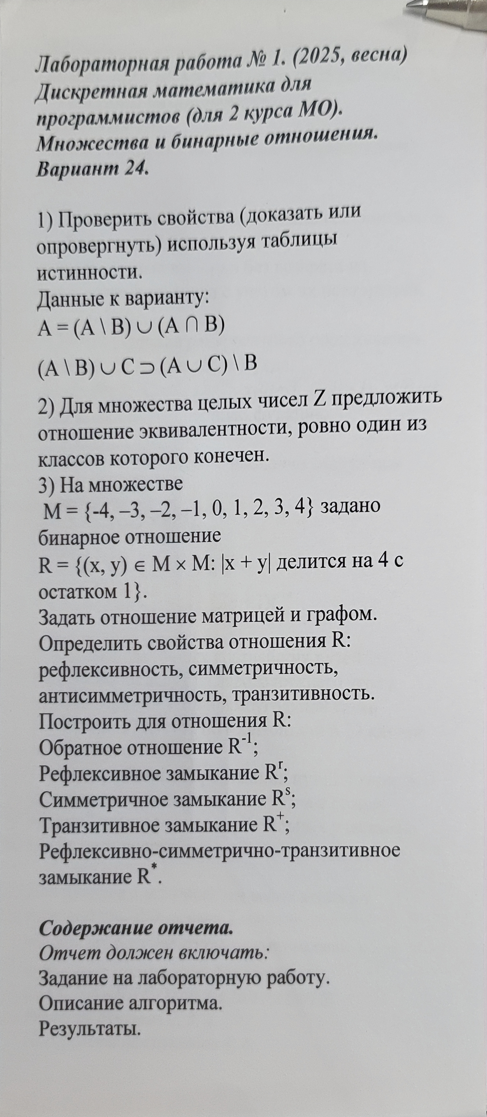

Решение:

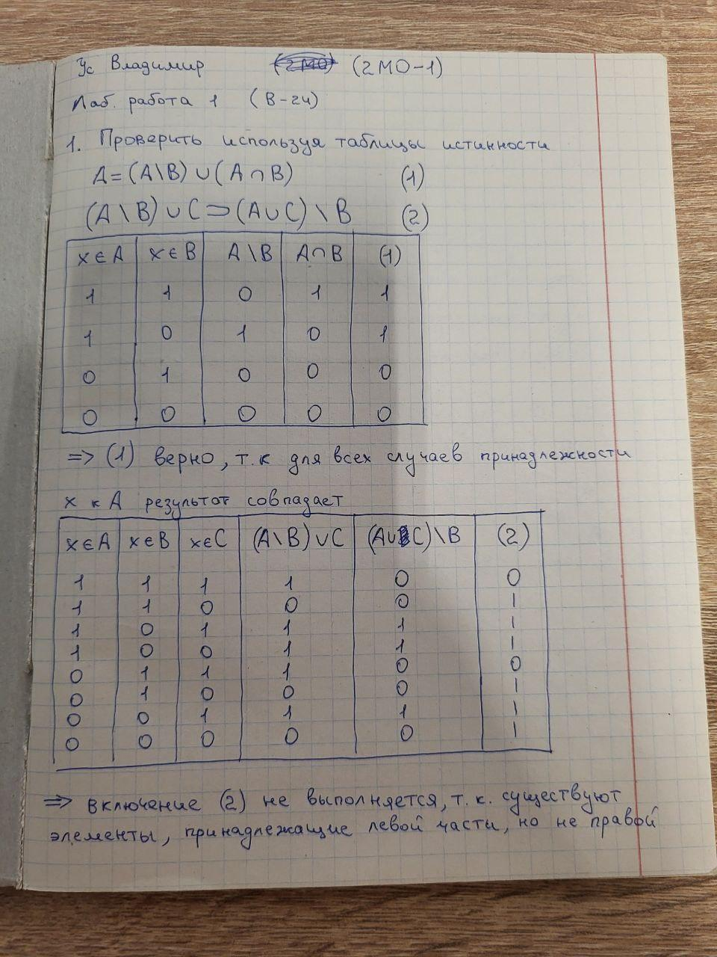

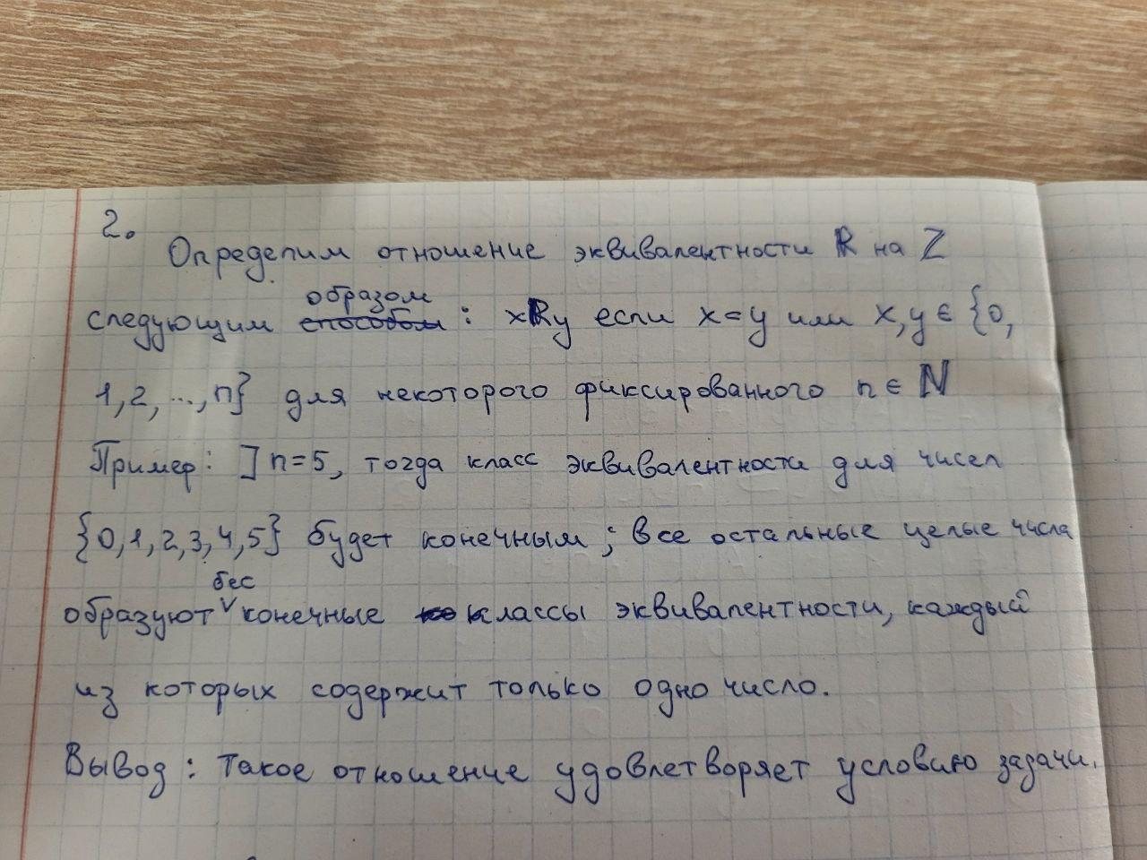

## 3. Бинарное отношение на множестве M

Множество: M = {-4, -3, -2, -1, 0, 1, 2, 3, 4}

Бинарное отношение: R = {(x, y) ∈ M × M : |x + y| делится на 4 с остатком 1}

Найденные пары отношения:

[(-4, -1), (-4, 3), (-3, -2), (-3, 2), (-3, 4), (-2, -3), (-2, 1), (-2, 3), (-1, -4), (-1, 0), (-1, 2), (0, -1), (0, 1), (1, -2), (1, 0), (1, 4), (2, -3), (2, -1), (2, 3), (3, -4), (3, -2), (3, 2), (4, -3), (4, 1)]

### Матрица отношения R

|  |  |  |  |  |  |  |  |  |  |
| --- | --- | --- | --- | --- | --- | --- | --- | --- | --- |
|  | -4 | -3 | -2 | -1 | 0 | 1 | 2 | 3 | 4 |
| -4 | 0 | 0 | 0 | 1 | 0 | 0 | 0 | 1 | 0 |
| -3 | 0 | 0 | 1 | 0 | 0 | 0 | 1 | 0 | 1 |
| -2 | 0 | 1 | 0 | 0 | 0 | 1 | 0 | 1 | 0 |
| -1 | 1 | 0 | 0 | 0 | 1 | 0 | 1 | 0 | 0 |
| 0 | 0 | 0 | 0 | 1 | 0 | 1 | 0 | 0 | 0 |
| 1 | 0 | 0 | 1 | 0 | 1 | 0 | 0 | 0 | 1 |
| 2 | 0 | 1 | 0 | 1 | 0 | 0 | 0 | 1 | 0 |
| 3 | 1 | 0 | 1 | 0 | 0 | 0 | 1 | 0 | 0 |
| 4 | 0 | 1 | 0 | 0 | 0 | 1 | 0 | 0 | 0 |

### Граф отношения R

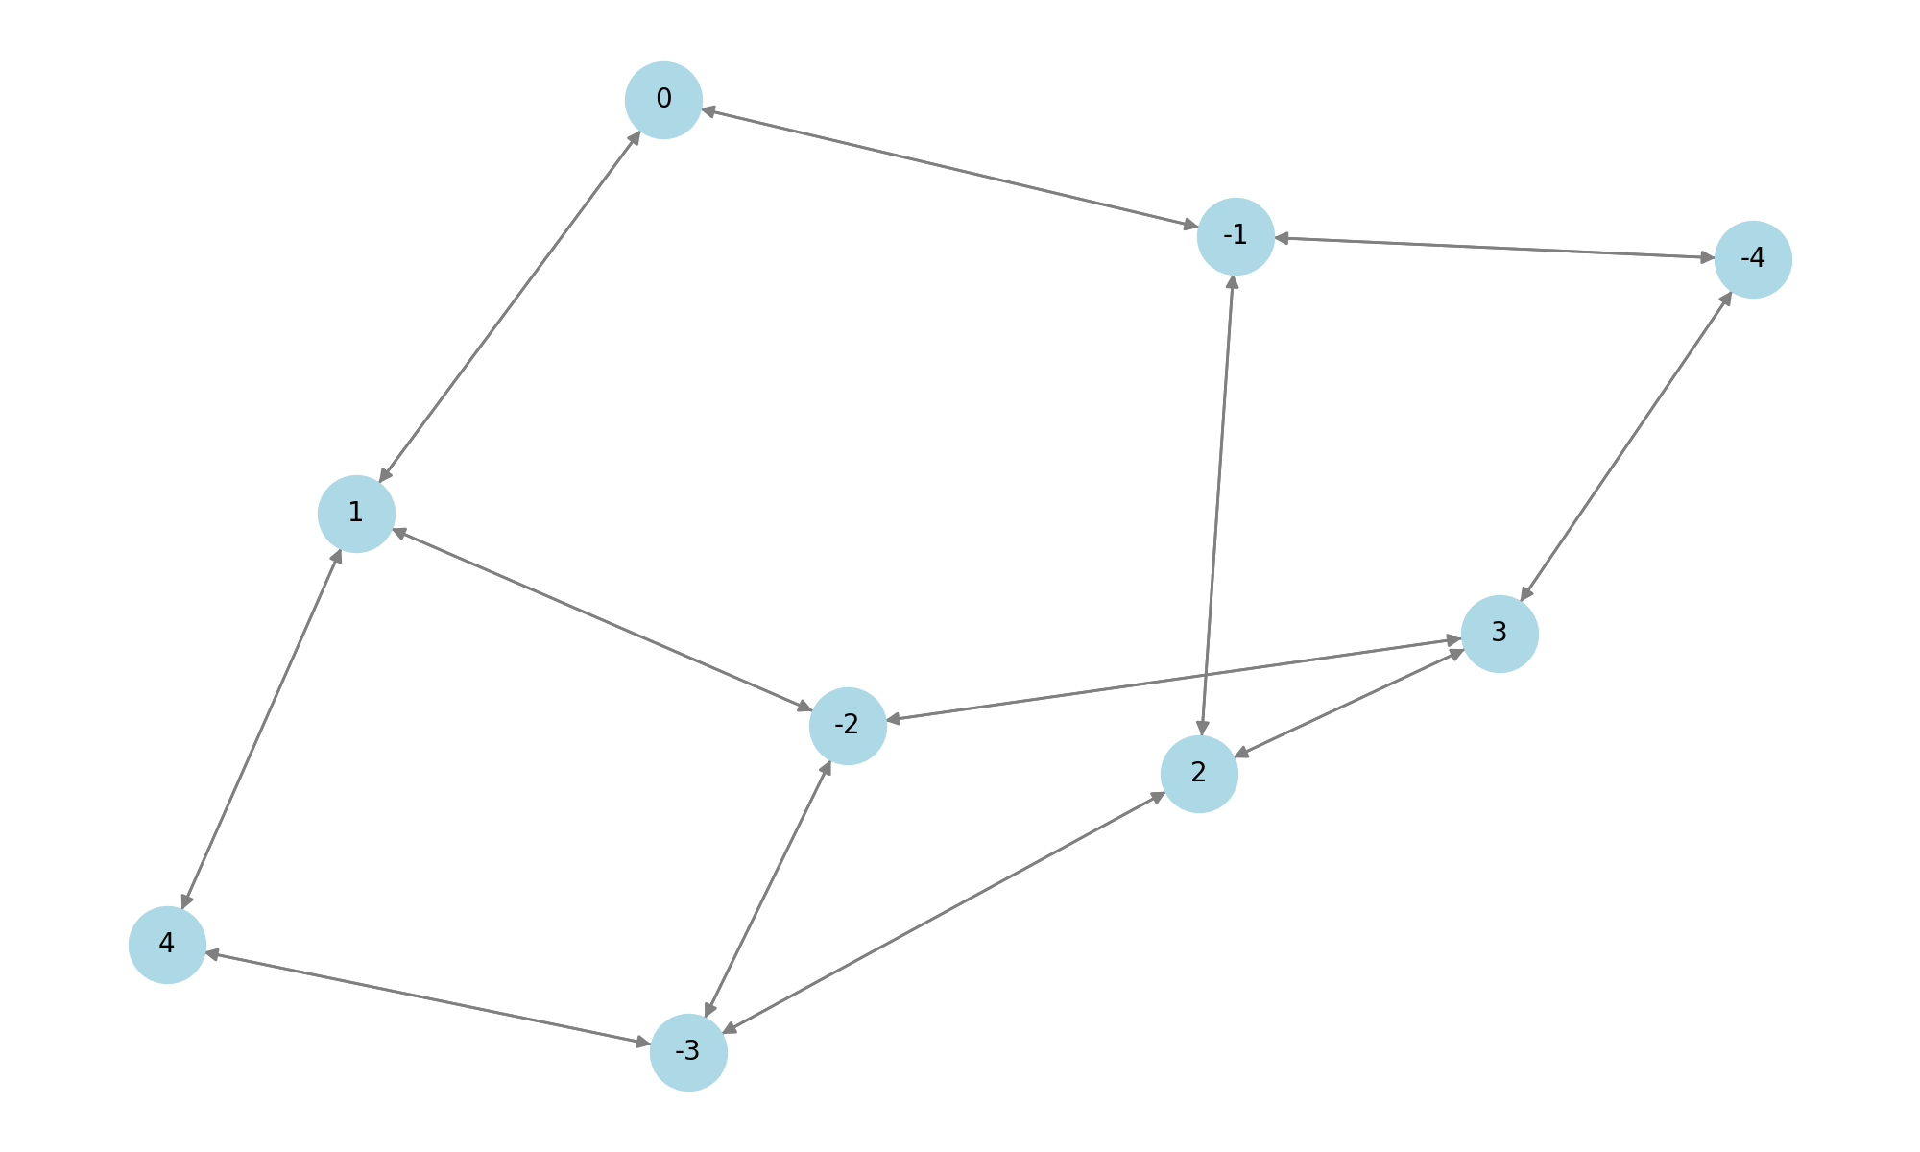

### Свойства отношения

Рефлексивность: не выполняется.

Симметричность: не выполняется.

Антисимметричность: не выполняется.

Транзитивность: не выполняется.

### Замыкания

Обратное отношение R⁻¹:

[(-1, -4), (3, -4), (-2, -3), (2, -3), (4, -3), (-3, -2), (1, -2), (3, -2), (-4, -1), (0, -1), (2, -1), (-1, 0), (1, 0), (-2, 1), (0, 1), (4, 1), (-3, 2), (-1, 2), (3, 2), (-4, 3), (-2, 3), (2, 3), (-3, 4), (1, 4)]

Симметрическое замыкание Rˢ:

[(3, -2), (4, -3), (1, 0), (-4, -1), (-2, 1), (-3, 2), (0, -1), (0, 1), (2, -1), (-2, -3), (-4, 3), (-1, 0), (-2, 3), (3, -4), (3, 2), (4, 1), (-3, -2), (-3, 4), (2, -3), (1, -2), (1, 4), (2, 3), (-1, -4), (-1, 2)]

Рефлексивное замыкание Rʳ:

[(3, -2), (4, -3), (1, 0), (-4, -1), (-2, 1), (-3, 2), (0, -1), (0, 1), (2, -1), (-2, -3), (-4, 3), (-1, 0), (-2, 3), (3, -4), (3, 2), (4, 1), (-3, -2), (-3, 4), (2, -3), (1, -2), (1, 4), (2, 3), (-1, -4), (-1, 2), (-4, -4), (-3, -3), (-2, -2), (-1, -1), (0, 0), (1, 1), (2, 2), (3, 3), (4, 4)]

Транзитивное замыкание R⁺:

[(-4, -4), (-4, -3), (-4, -2), (-4, -1), (-4, 0), (-4, 1), (-4, 2), (-4, 3), (-4, 4), (-3, -4), (-3, -3), (-3, -2), (-3, -1), (-3, 0), (-3, 1), (-3, 2), (-3, 3), (-3, 4), (-2, -4), (-2, -3), (-2, -2), (-2, -1), (-2, 0), (-2, 1), (-2, 2), (-2, 3), (-2, 4), (-1, -4), (-1, -3), (-1, -2), (-1, -1), (-1, 0), (-1, 1), (-1, 2), (-1, 3), (-1, 4), (0, -4), (0, -3), (0, -2), (0, -1), (0, 0), (0, 1), (0, 2), (0, 3), (0, 4), (1, -4), (1, -3), (1, -2), (1, -1), (1, 0), (1, 1), (1, 2), (1, 3), (1, 4), (2, -4), (2, -3), (2, -2), (2, -1), (2, 0), (2, 1), (2, 2), (2, 3), (2, 4), (3, -4), (3, -3), (3, -2), (3, -1), (3, 0), (3, 1), (3, 2), (3, 3), (3, 4), (4, -4), (4, -3), (4, -2), (4, -1), (4, 0), (4, 1), (4, 2), (4, 3), (4, 4)]

Полное замыкание R*:

[(-4, -4), (-4, -3), (-4, -2), (-4, -1), (-4, 0), (-4, 1), (-4, 2), (-4, 3), (-4, 4), (-3, -4), (-3, -3), (-3, -2), (-3, -1), (-3, 0), (-3, 1), (-3, 2), (-3, 3), (-3, 4), (-2, -4), (-2, -3), (-2, -2), (-2, -1), (-2, 0), (-2, 1), (-2, 2), (-2, 3), (-2, 4), (-1, -4), (-1, -3), (-1, -2), (-1, -1), (-1, 0), (-1, 1), (-1, 2), (-1, 3), (-1, 4), (0, -4), (0, -3), (0, -2), (0, -1), (0, 0), (0, 1), (0, 2), (0, 3), (0, 4), (1, -4), (1, -3), (1, -2), (1, -1), (1, 0), (1, 1), (1, 2), (1, 3), (1, 4), (2, -4), (2, -3), (2, -2), (2, -1), (2, 0), (2, 1), (2, 2), (2, 3), (2, 4), (3, -4), (3, -3), (3, -2), (3, -1), (3, 0), (3, 1), (3, 2), (3, 3), (3, 4), (4, -4), (4, -3), (4, -2), (4, -1), (4, 0), (4, 1), (4, 2), (4, 3), (4, 4)]